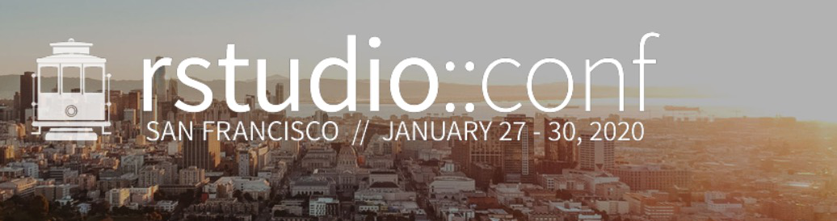

250 Northern Ave  
Boston, MA 02210

January 10, 2020

Dear RStudio::conf(2020) workshop attendee:

Thank you for registering for a RStudio::conf 2020 workshop! At RStudio::conf 2020, you will be participating in one of the largest R learning experiences in the world. You’ll be one of more than 1,300 students participating in 19 workshops taught by some of the most well-known R instructors anywhere. We hope you are as excited for this opportunity as we are.

To make the most of your time at RStudio::conf, we strongly recommend you do some preparation before you arrive.

## **Prior to RStudio::conf**

Your workshop experience will go more smoothly if you do some preparation before RStudio::conf begins. No matter how good the Internet access is at the hotel, it won’t be able to cope with 1,300+ people all downloading R and RStudio in the first 30 minute of the workshop.

* **Identify a laptop to bring with you to the workshop.** All of our workshops include exercises which require a computer. If you don’t have a laptop with you, you’ll miss out on much of the value of the workshop. If you don’t own a laptop, you may want to rent one from one of several computer rental services in San Francisco.
* **Ensure you can install software on your laptop.** Some companies “lock down” laptops so that no software can be installed without the approval of IT. Should you have one of those computers, we highly encourage you to see if you can bring a personal laptop or, as noted above, rent one from one of the several computer rental services in San Francisco.
* **Make sure you pack your power cord!** Workshop exercises will keep you busy from 9 am to 5 pm each day, which will exceed the battery life of most laptops. We’ll provide power strips in the workshop rooms, but you’ll need your power supply to take advantage of them.
* **Please ensure your laptop has the following software installed:**
  + A recent version of R (>=3.6.0), which is available for free at <https://cloud.r-project.org/>
  + A recent version of RStudio Desktop (>=1.2), available for free ([RStudio Desktop Open Source License](https://www.rstudio.com/products/rstudio/download/#download))
  + A modern browser. Supported browsers include:
    - Microsoft Edge
    - Internet Explorer 11+
    - Chrome
    - Safari
    - Firefox
* **Check community.rstudio.com for instructions specific to your workshop.** Each workshop has its own community.rstudio.com space where instructors can post information and where you can ask questions. The links for each community.rstudio.com space can be found at the following web page:

<https://community.rstudio.com/t/about-workshops-at-rstudio-conference-2020/49089>

Be sure to regularly bookmark and check your page before you arrive in San Francisco so that you don’t have to waste time on the day of your workshop getting set up.

## **On the day your workshop begins**

* **Arrive early.** Getting more than 1,300 people registered and badged is going to take time. You can avoid waiting in long lines by arriving early, getting some coffee, and finding a great seat. Registration starts at 6:30 am. Better yet, if you are local to San Francisco, come register on Sunday night between 4 and 7 pm.
* **Don’t forget your laptop, power cord, and children.** While we’ll provide power and Internet, you’ll need to bring your laptop and power cord to your workshop session. Don’t forget that if you signed up for day care when you registered, you can drop off your children at our private day care service beginning at 8 am and can pick them up before 6 pm.
* **Plan for two full days.** Workshops will begin at 9 am and end by 5 pm and are structured as 4 90-minute sessions each day. Lunch will be provided from 12:30 to 1:30, and half-hour breaks will be at 10:30 and 3:30.
* **Wear layers.** We’ll do our best to keep the workshop rooms comfortable, but we know that no matter what temperature is set, some will find the room temperatures too hot or too cold. We recommend wearing light clothes in case the room is warm and bringing a sweater or jacket in case it is too cold.

## **Join the community after your workshop**

Learning doesn’t end when the workshops finish. Open bar receptions between 5:30 and 7:30 on both Monday and Tuesday evenings will give you a chance to talk about what you’ve learned in a less formal environment and to network with instructors and students from other workshops.

We look forward to seeing you in San Francisco!

Carl Howe, Director of Education  
Rstudio